Rule Book

How to map test data document to Results.csv record?

For each record in ‘Results.csv’, find the corresponding filename in ‘Test Data’ folder by ‘Credit Name’ value.
Example:
For record:
Filename is ‘Jeannette_PA_8612_G O Municipality & County_City _2016.pdf’

Rules to Extract Values:

Accounting Basis:
- In each document, look for the heading “Basis of Accounting”.
- Identify the word associated with next occurence of “Basis of Accounting”:
  - ‘Accrual’, ‘Cash’, ‘Modified Accrual’, ‘Modified Cash’, ‘Regulatory’
- The associated keyword is the value for ‘Accounting Basis’
- In case no keyword is identified, place ‘na’ as the value

Balance Sheet Cash:
- Search for ‘Balance Sheet Governmental Funds’ table
- Extract & sum up the values under following columns, if available:
  - Cash
  - Cash and Demand Accounts (if cash is not given separately)
  - Cash and investments (if cash is not given separately)
  - Cash and deposits (if cash is not given separately)
  - Cash and time deposits (if cash is not given separately)
  - cash and equivalents
  - Cash in county Treasury
  - Cash in Revolving Fund
  - Cash on Hand
  - Cash in Banks
  - Collection Awaiting Deposit
  - non-pooled cash, petty cash, pooled cash
  - demand deposit
  - Demand Accounts
  - equity in cash and investments
  - equity in Pooled Cash and Cash Equivalents
- Enter the total amount as ‘Balance Sheet Cash’

Steps to Extract Pension Plan Details:

- Search for ‘Pension Plans’ in each document
- For each Pension Plan name occurence:
  - Search for string ‘measured’ or ‘measured as of’
    - The associated date value is the ‘Pension Plan Measurement Date’ for respective pension plan
  - Next, search for tabular data related to keywords ‘Net Change in Pension Liability’
    - In the table, search for ‘Total Pension Liability’
      - In case it doesn’t occur in the current table, continue the search pattern
    - Extract the value for ‘Total Pension Liability’ for corresponding ‘Pension Plan Measurement Date’ (refer screenshots below)
    - This value is the corresponding ‘Pension Plan Liability’
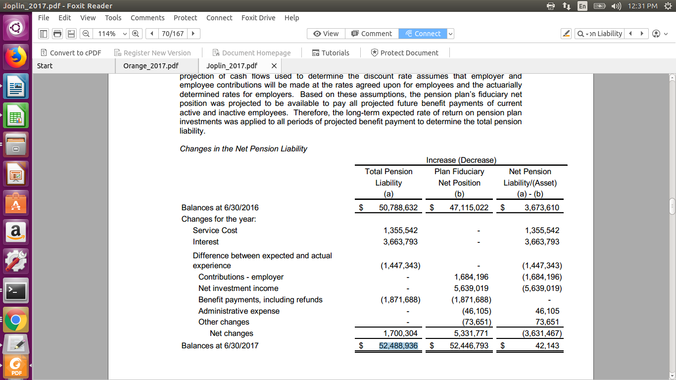

    - Repeat Search for all Pension Plans in each document
  - Sort the Pension Plans on descending order of ‘Total Pension Liability’ value
  - Map the Pension Plan names as mentioned here
  - The details of top 2 Pension Plans are to be labelled as :
    - Pension Plan 1 Name, Pension Plan 1 Measurement Date, Pension Plan 1 Total Pension Liability
    - Pension Plan 2 Name, Pension Plan 2 Measurement Date, Pension Plan 2 Total Pension Liability
  - Note:
    - In case no Pension Plan name or date or liability value is available, fill values as ‘Not Found’, ‘No Date’ and ‘0’ respectively.

